TalentOps Landing Page

This document consolidates the recent strategic gap analysis with practical UI and
content critiques to align the TalentOps landing page with our core vision: moving from a
traditional SaaS tool to an AI-powered operational system for professional services.

1. Structural & UI Critiques (The "Show, Don't Just Tell" Gap):
Currently, the landing page explains the problems we solve but fails to visually
demonstrate how we solve them or what the system actually looks like in practice. The
following areas need immediate attention:
● Visual Evidence of Modules: We are talking about our features without showing
them. We need to introduce physical UI snapshots (tab pictures) directly from the
app for our core modules:
○ Task Module
○ Finance Module
○ People Operations (Attendance)
○ Communication Module, billings etc…
● Addressing the Core Pain Points: The messaging is currently missing the
emotional and operational hooks. We need to explicitly state that we solve the
problem of: "Losing track of who is doing what, who is burning out, and where the
hiring gaps are."
● Hero Section Redesign: The current hero component is visually distracting. It
needs to be streamlined to immediately capture attention without overwhelming the
user.
● Content Cleanup: There are repetitive statements throughout the page, and the
vocabulary used is unnecessarily complex. The copy needs to be simplified for
immediate clarity.

2. Strategic Messaging Shifts (Addressing the Gap Analysis)
To position TalentOps accurately for our target market, the underlying narrative must shift across several dimensions:
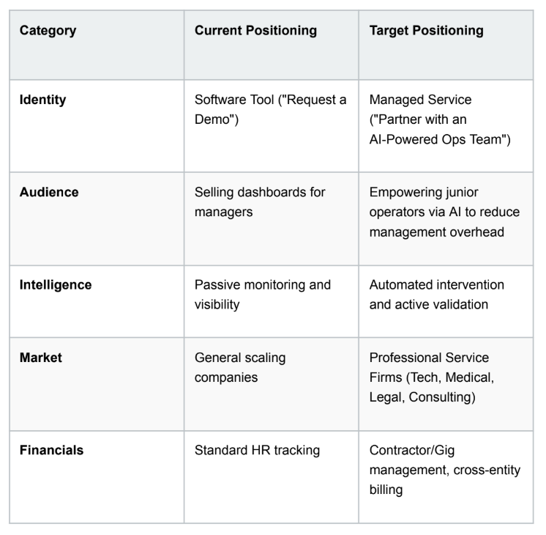

3. Action Items

These are the immediate next steps to translate these critiques into a functional page
update. These items are broken down into manageable tasks:
1. Revamp the Hero Section: Redesign the top component to be less distracting.
Update the primary Call-to-Action (CTA) from "Request a Demo" to "Partner with an AI-Powered Operations Team."
2. Design Module Showcases: Gather or design clean, high-fidelity screenshots/tab
pictures of the Task, Finance, People Operations, and Communication modules. Place these alongside the text explaining what they do.
3. Simplify and De-duplicate Content: Do a complete read-through of the page.
Remove any repeated paragraphs. Rewrite complex, jargon-heavy sentences into
plain, easy-to-understand English.
4. Integrate Missing Pain Points: Add a dedicated section or bullet points that
explicitly call out how the platform prevents burnout, tracks who is doing what, and
identifies hiring gaps.
5. Update the Technical & Target Market Copy: Ensure the text specifically
mentions the 3-tier architecture (Deputy → Intermediary → Expert) and calls out our
ideal customers: Tech, Medical, Legal, and Consulting firms handling complex
contractor setups.

